Cameron Gayford January 23, 2014 CIS 219, Habermas Exercises 1.4 & 1.5

1.4

Code:

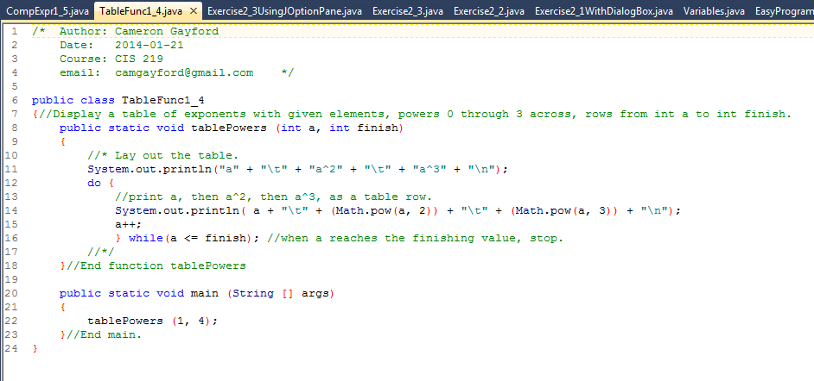

Output:

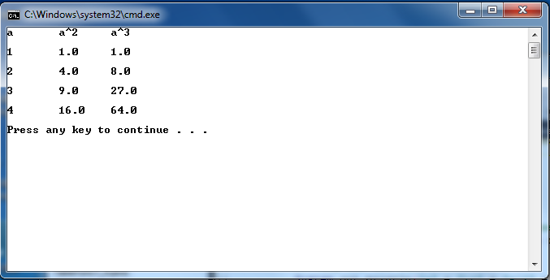

Cameron Gayford January 23, 2014 CIS 219, Habermas Exercises 1.4 & 1.5

1.5

Code:

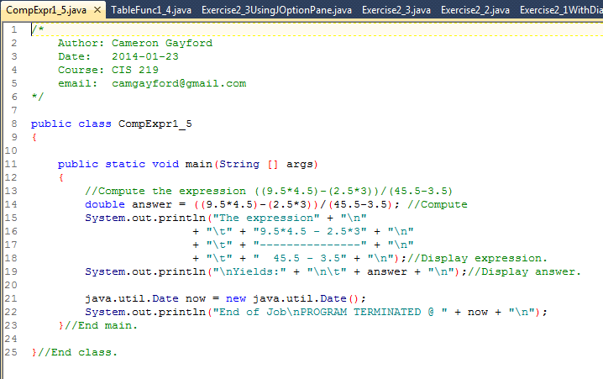

Output:

